

User Manual

**Table of Contents**

**Introduction** **3**

Changing Background 4

**Inserting/Deleting Slides** **5-6**

Inserting 5-6

Deleting 6

**What to Write?** **7-9**

**Adding Images/Videos** **10**

Adding Images 10-11

Adding Videos 12-14

**Saving Progress** **15-16**

**Adding Comments** **17**

**Presenting Slide** **18-19**

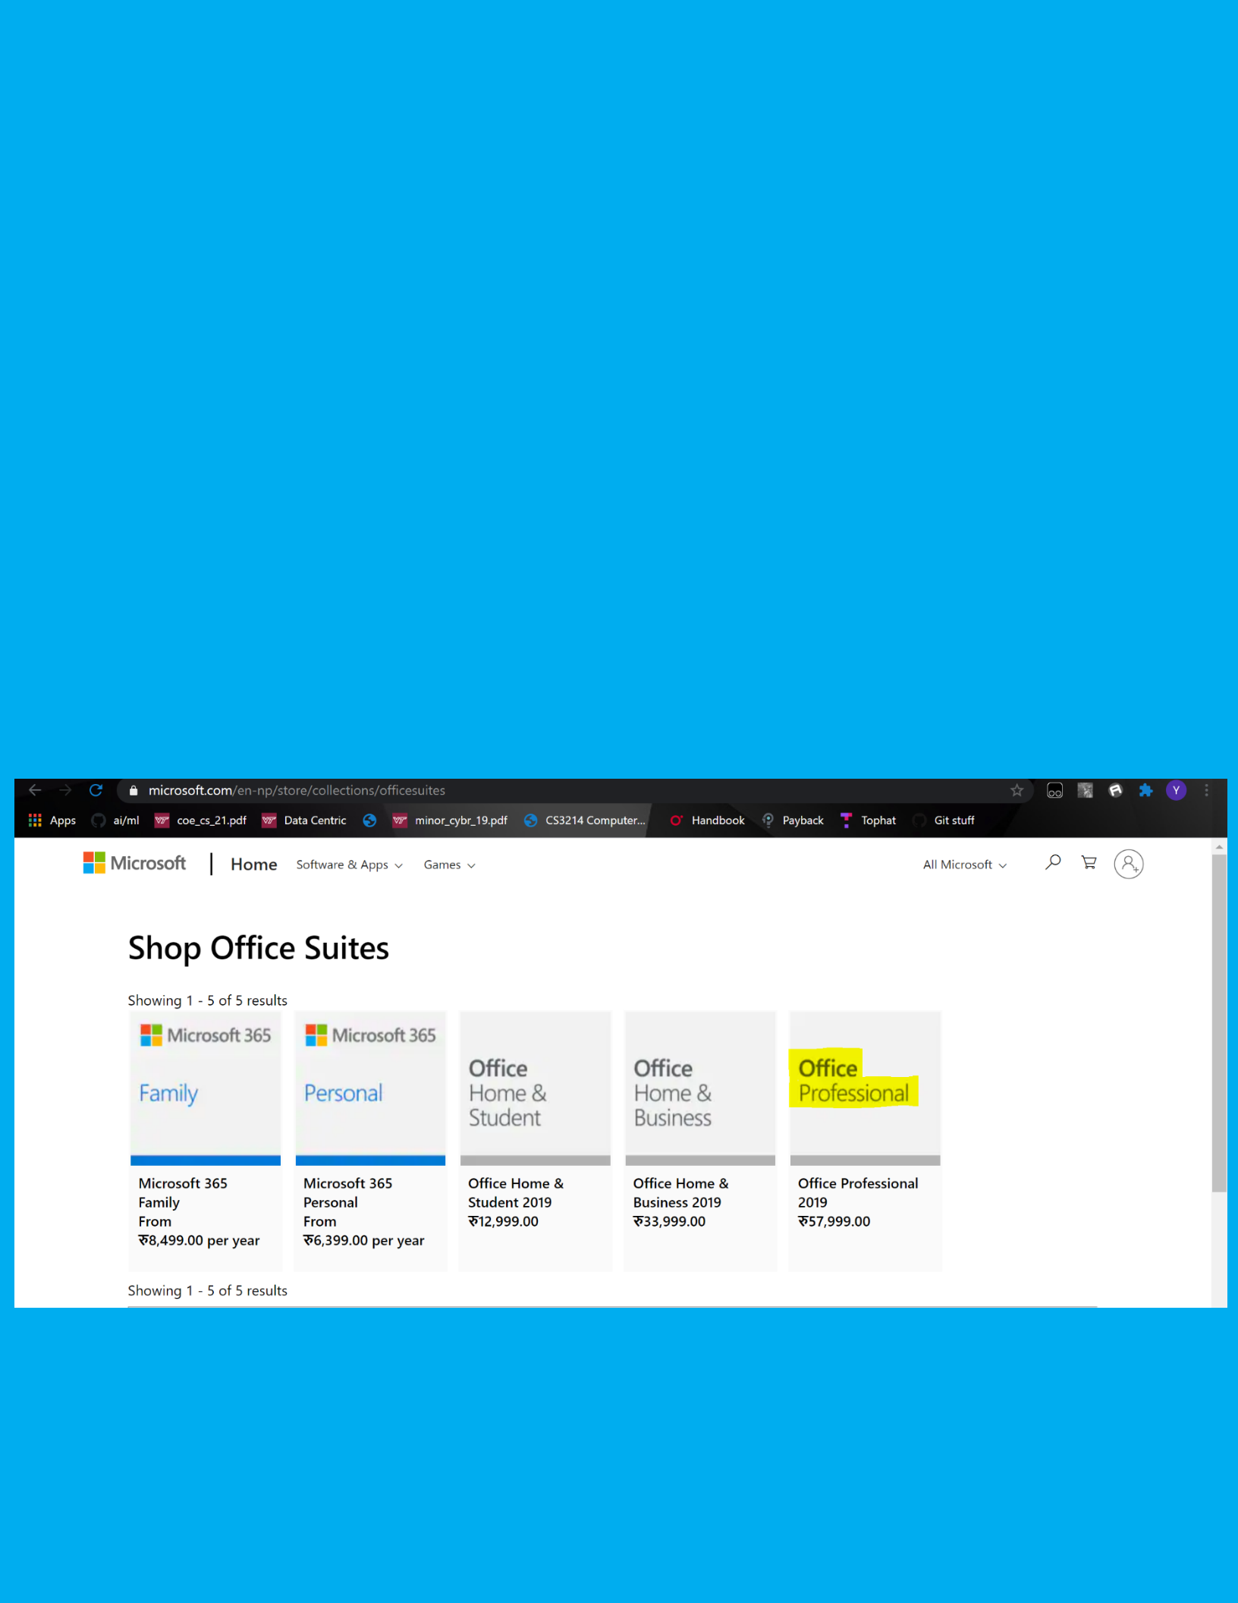**Introduction**

Microsoft PowerPoint is a presentation program that allows the user to create and show slides in order to support a presentation by combining text, graphics, and multi-media content. It was released in 1987 and available in 102 languages. The goal of this documentation is to teach the basics of using PowerPoint. The digital literacy competencies that are present include but not limited to collaboration, creativity, communication, curate information. This tool is excellent for creating a presentation with a group and allows you to create a presentation that has no limitation on creativity. It is an excellent way in communicating information on topics and helpful in organizing the way the information is communicated. The document will teach how to create a basic presentation by inserting and deleting slides, changing backgrounds of the slides, adding images/videos, presentation mode, saving, etc. To begin, a Mac or Windows will be needed, as well as Microsoft Package from the image below. In this document, Microsoft Office Professional will be used, however, any of the other packages will have the same instructions/methods.

*Figure 1: These are the prices for Microsoft Packages in Nepal. The highlighted package is the package that is being used for this document. Any of these packages will be good. Each package offers a different number of benefits which can be found when clicking on a package.*

**Changing Background**

*Figure 2: The steps to change the background are highlighted and numbered in order.*

**The first step is to choose a theme/background that will go with the presentation you are trying to create. To choose a theme/background means to make your presentation a little more appealing to the audience and make the visualization better. In this image, I have chosen a blue background. There are a variety of options to choose from when it comes to choosing a theme/background for your presentation.**

1. Click Design tab (Labeled 1) on the top to take you to the page with all the backgrounds you can choose from.
2. The first 7 slides displayed on the left side with different backgrounds let you choose the design. The highlighted arrows (Labeled 2) let you look for more options. After choosing the background you like, the next 4 slides on the right-hand side of it lets you pick the color of the design (Labeled 3).
3. Another way to change background is to click Format Background (Labeled 4) on the far right, which will open a menu as shown in the image above. The menu will consist of different fills you can do and allows you to change color/pattern as well.

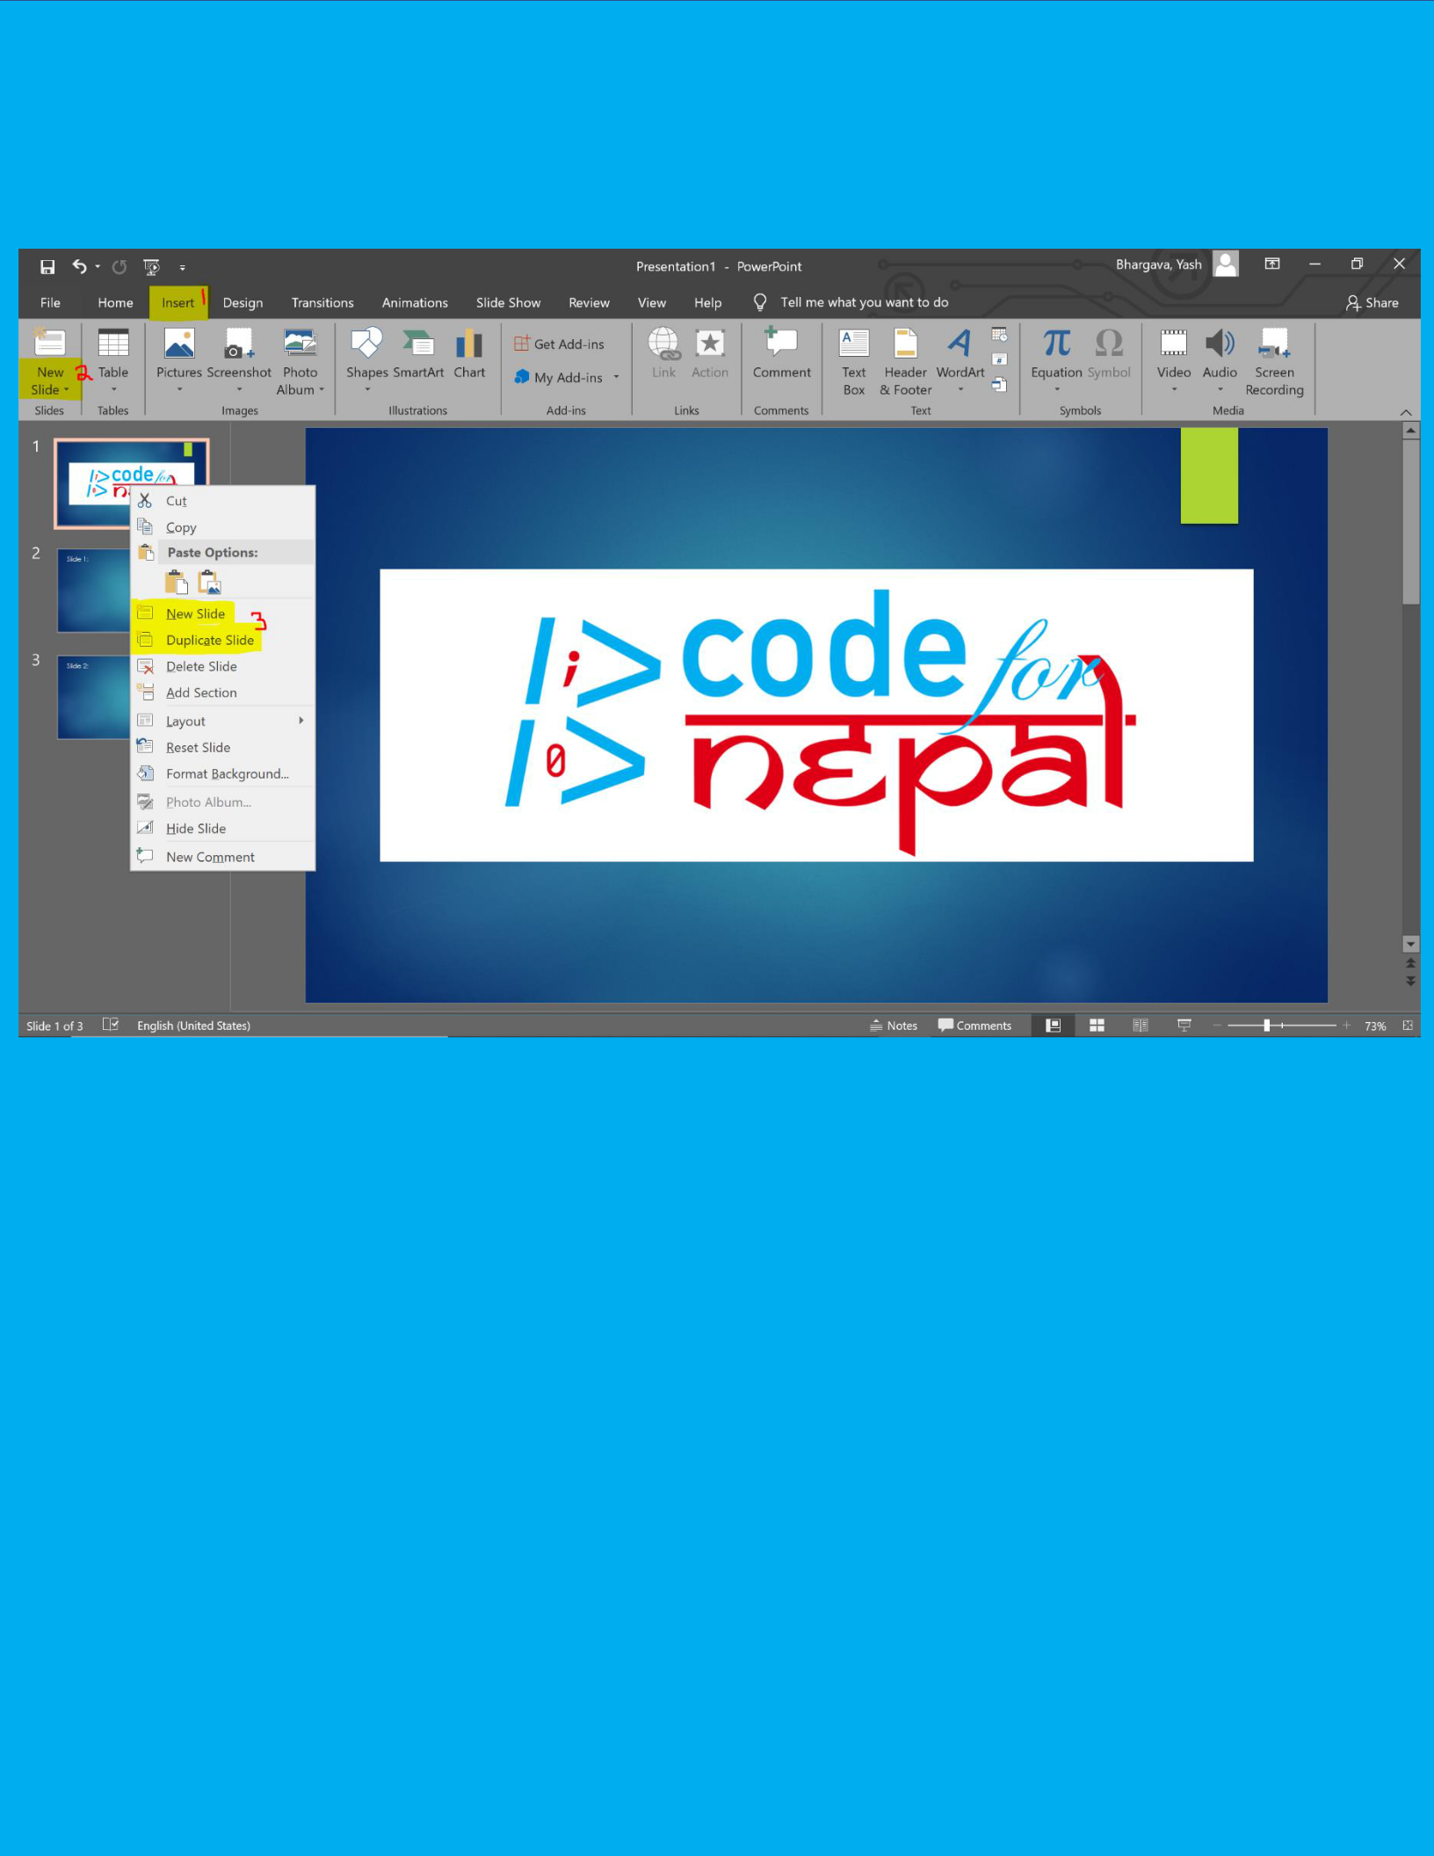**Inserting/Deleting Slide**

*Figure 3: Image of how to insert slides, labeled by number to distinguish the steps to take*

To insert/delete a slide means to add a page to add more information on (insert) or to remove any page(s) that is not needed or is extra (delete)

**Inserting (3 ways to do this)**

1. Select the slide on the left-hand side that you want to insert a slide after, and then press Enter on the keyboard. The selected slide will be highlighted with a yellowish color on the border.

**OR**

1. Select the slide on the left-hand side that you want to insert a slide after. Click insert tab on top as shown in figure 3 (Labeled 1) and then on left-hand side under the tab click New Slide (Labeled 2).

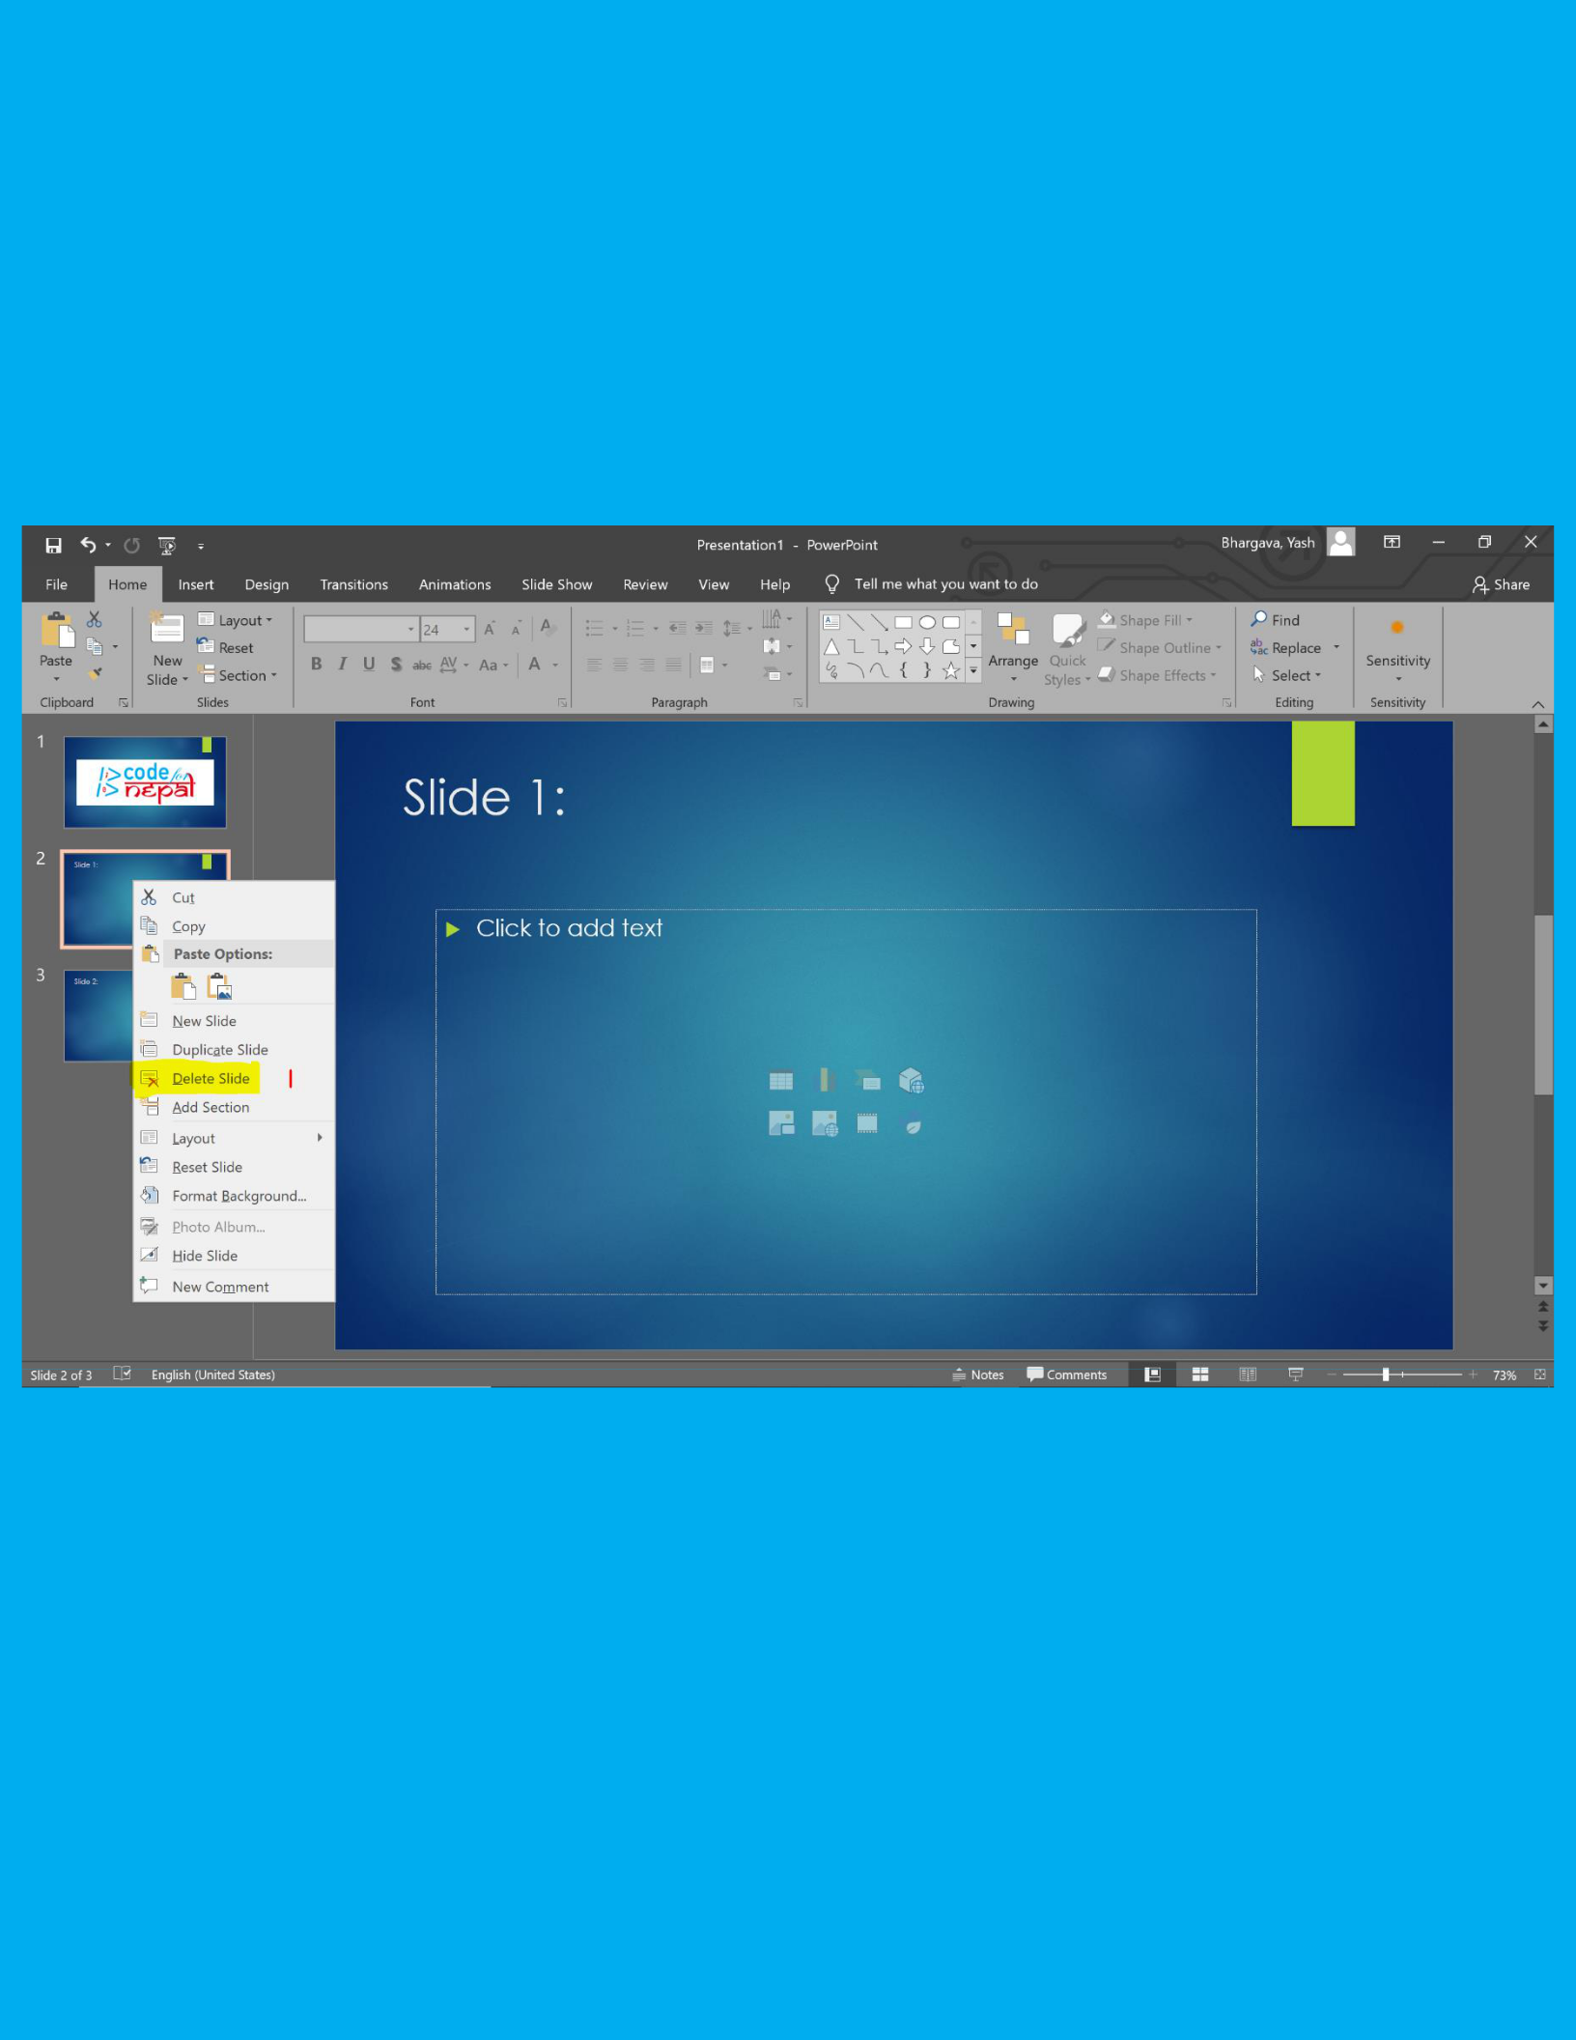**OR**

1. Select the slide on the left-hand side that you want to insert a slide after. Right click on the slide and then click on the words New Slide that are on the little menu that pops up. Highlighted and labeled 3 in figure 3. Duplicate slide makes a exact copy of selected slide.

**Deleting (2 ways to do this)**

*Figure 4: Image shows how to delete a slide*

1. Select the slide from the left-hand side and press Delete on your keyboard. The selected slide will be highlighted with a yellowish color on the border.

**OR**

1. Select the slide from the left-hand side that you want to delete. Right click on the slide and then click on the words Delete Slide that are on the little menu that pops up. As shown in figure 4 and labeled 1.

**What to write?**

PowerPoint is used to present ideas to an audience. The first thing would be to figure out what exactly will you present. On the title slide, you would want to put the topic of what you have chosen, who created the presentation, and when it was created. The second thing will be to actually put the information on slides after about the topic chosen.

An example of this would be say the topic is Water Crisis, and the information/images I would want to add to it would be things like what is water crisis and how can it be resolved. Figure 5-7 shows an example of the slides used in this presentation

*Figure 5: Example of a title slide. Topic in this example is Water Crisis in America. Created by John Doe on September 22nd, 2020*

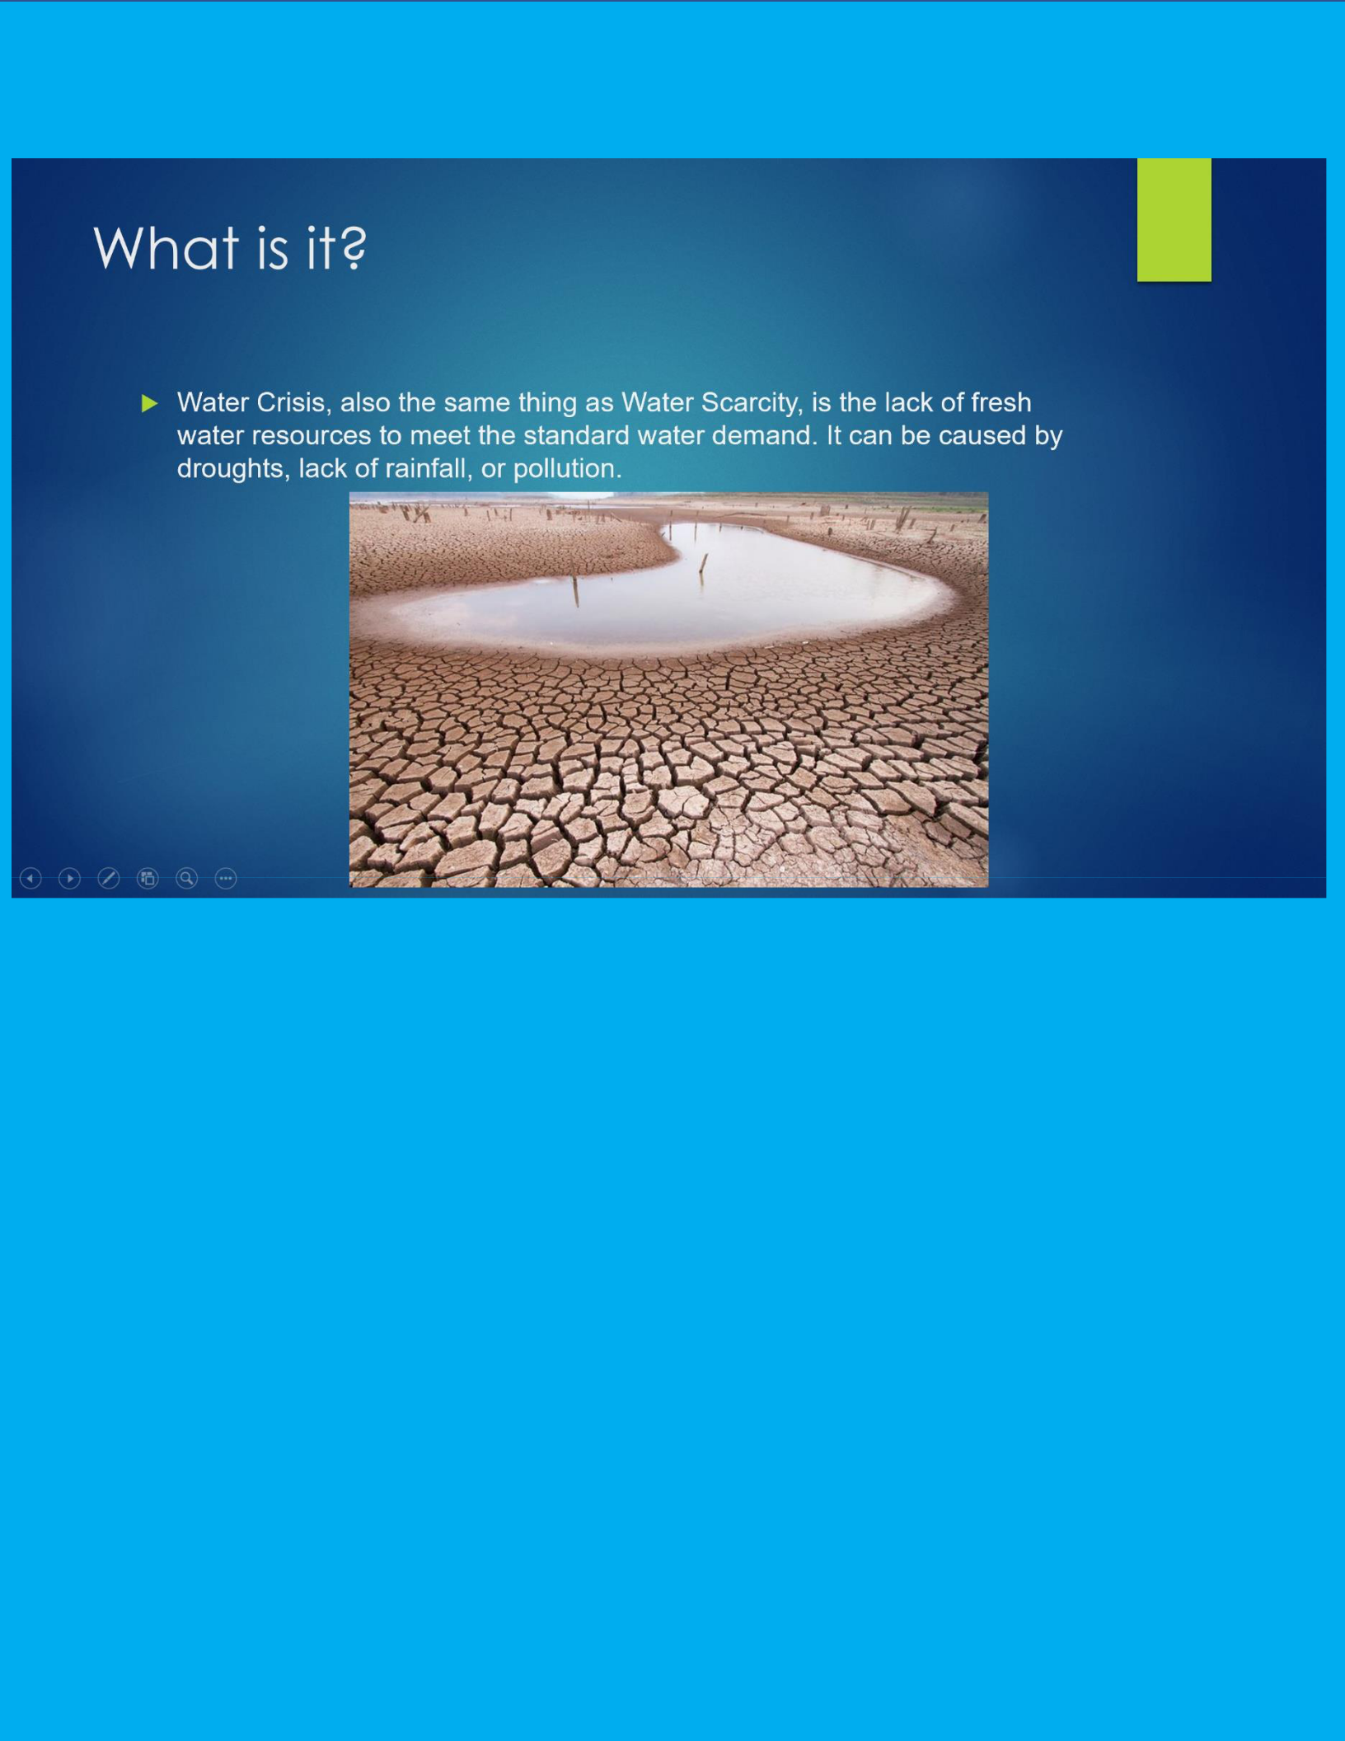

*Figure 6: Example of information to put about the topic, Water Crisis in America, and type of image to provide*

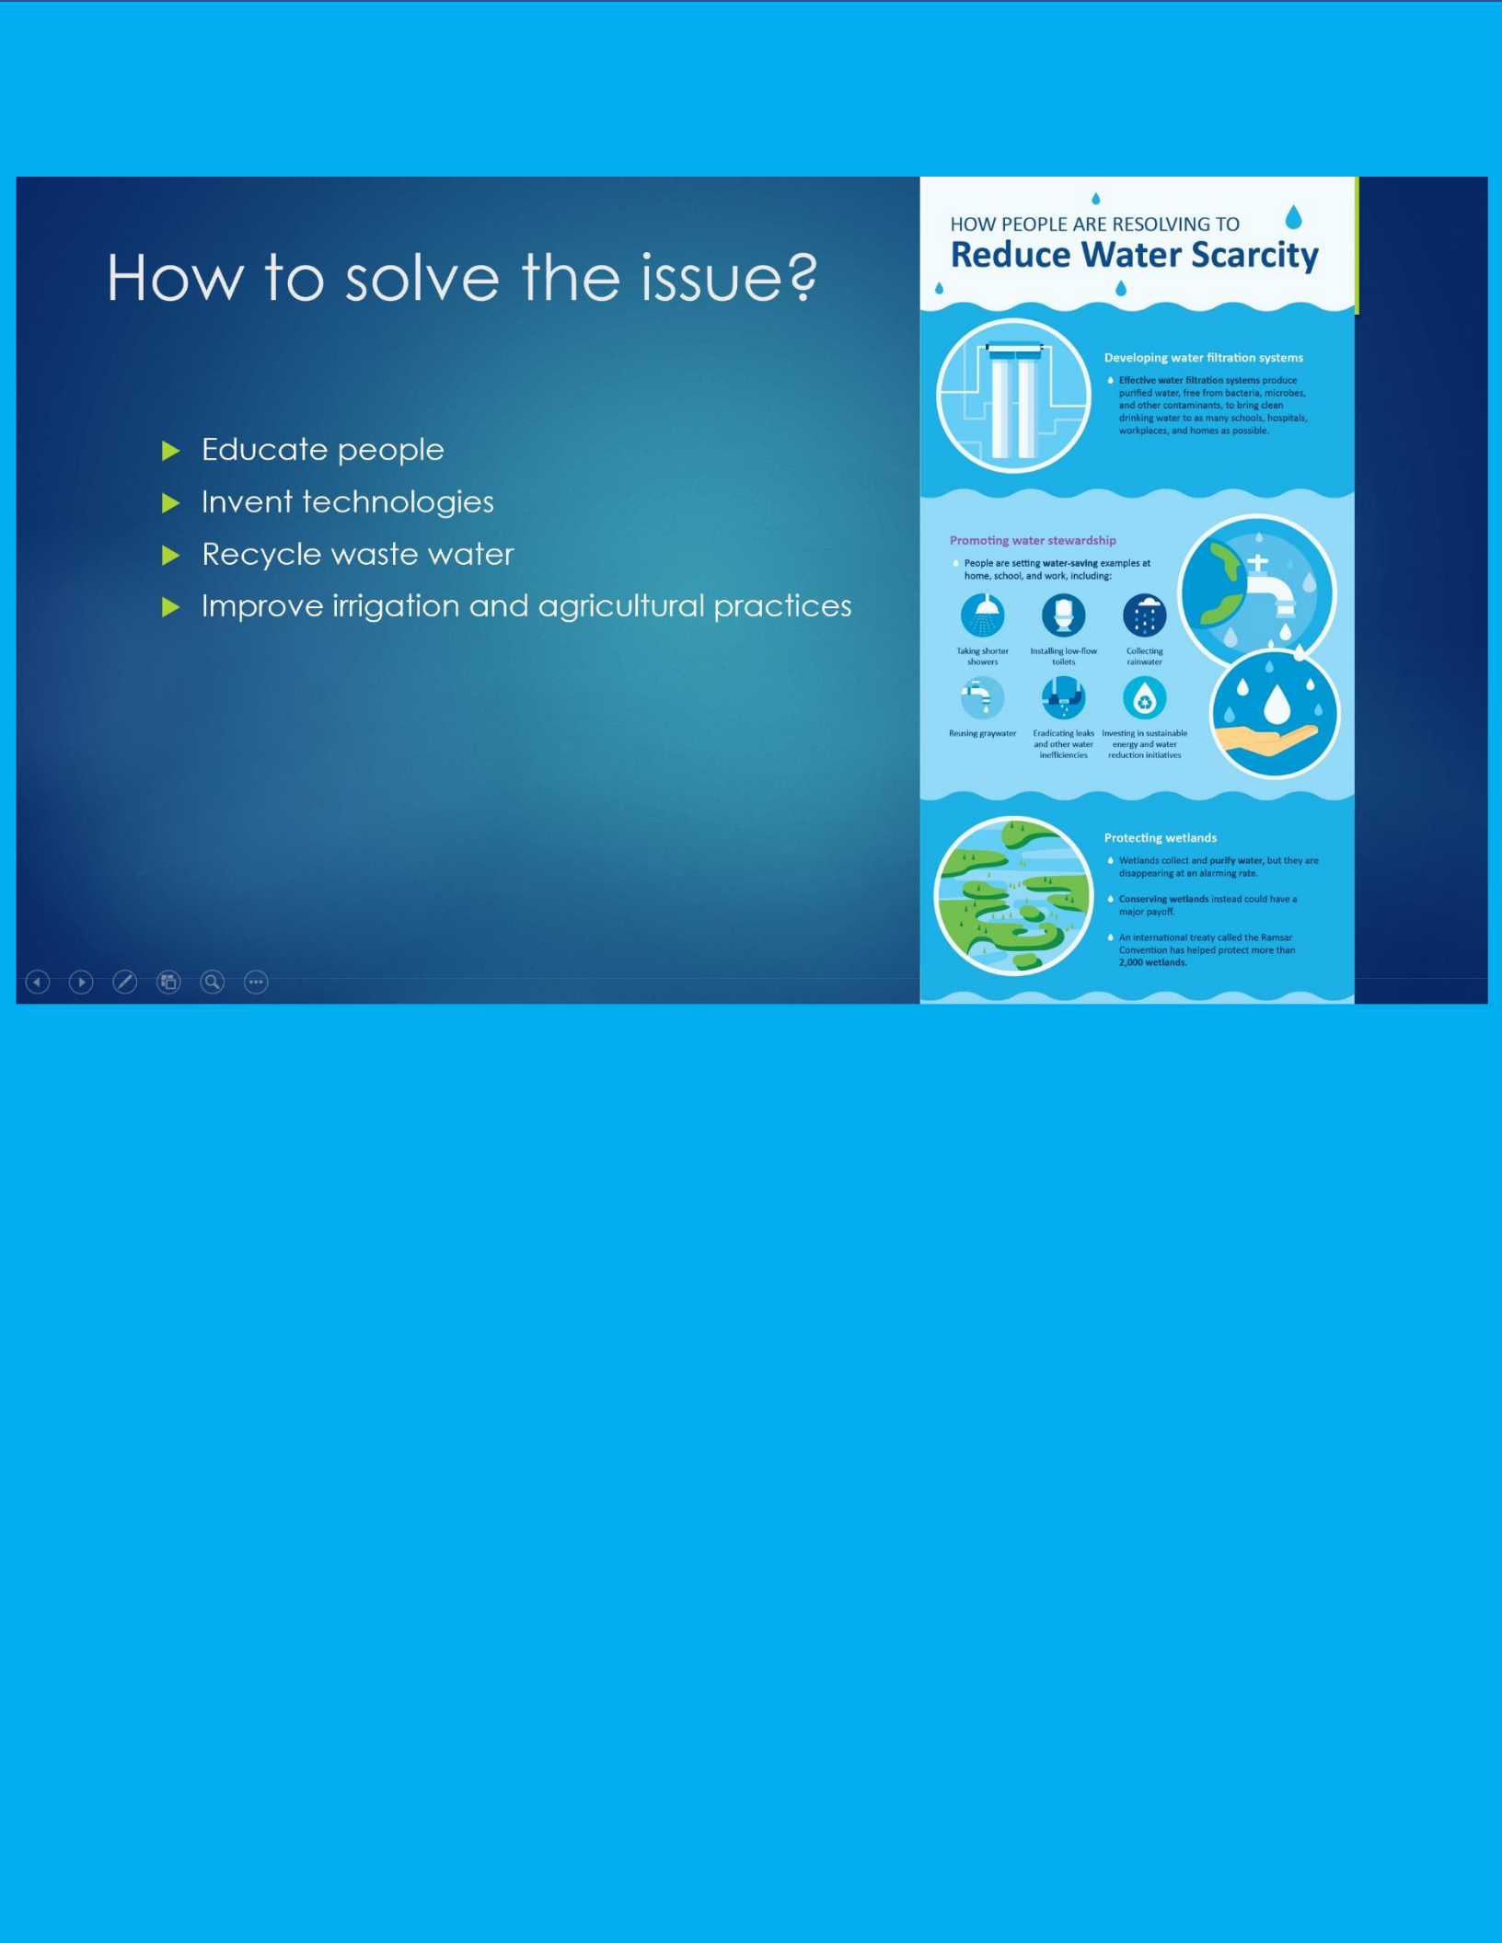

*Figure 7: Example of another slide and type of image/information to put on the page about the topic Water Crisis in America*

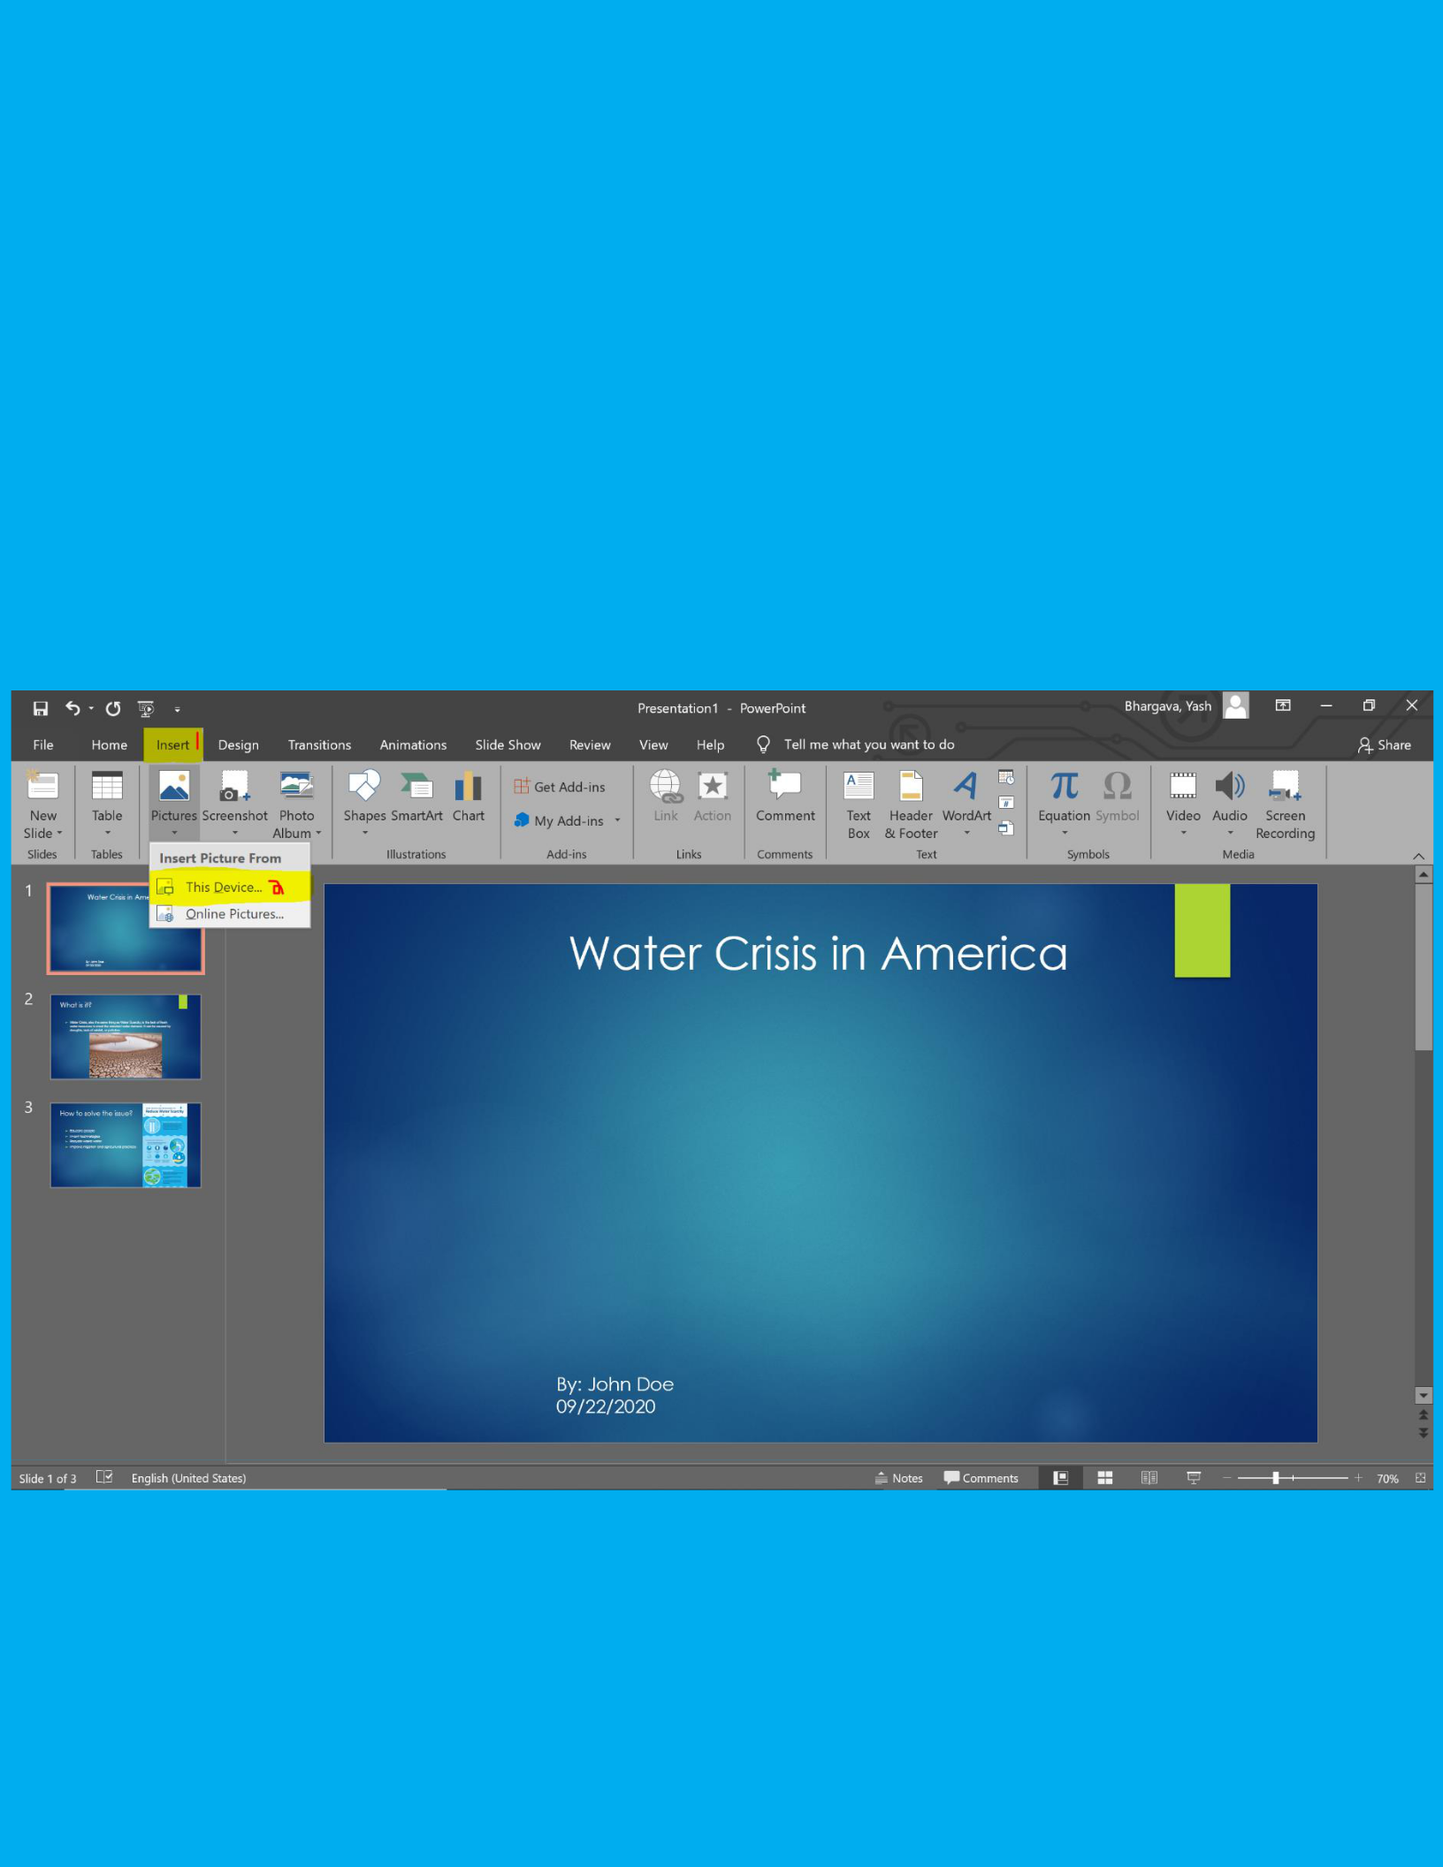**Adding Images/Video:**

The importance of adding an image or video is that it provides supporting details and/or visualization for the audience to see. So as explained in the section of what information to put on a slide, adding and image would be something to consider as it will add on extra information, support the topic, and make the presentation more appealing.

**Inserting Image**

*Figure 8: Image shows how to insert an image and the steps are distinguished by numbers*

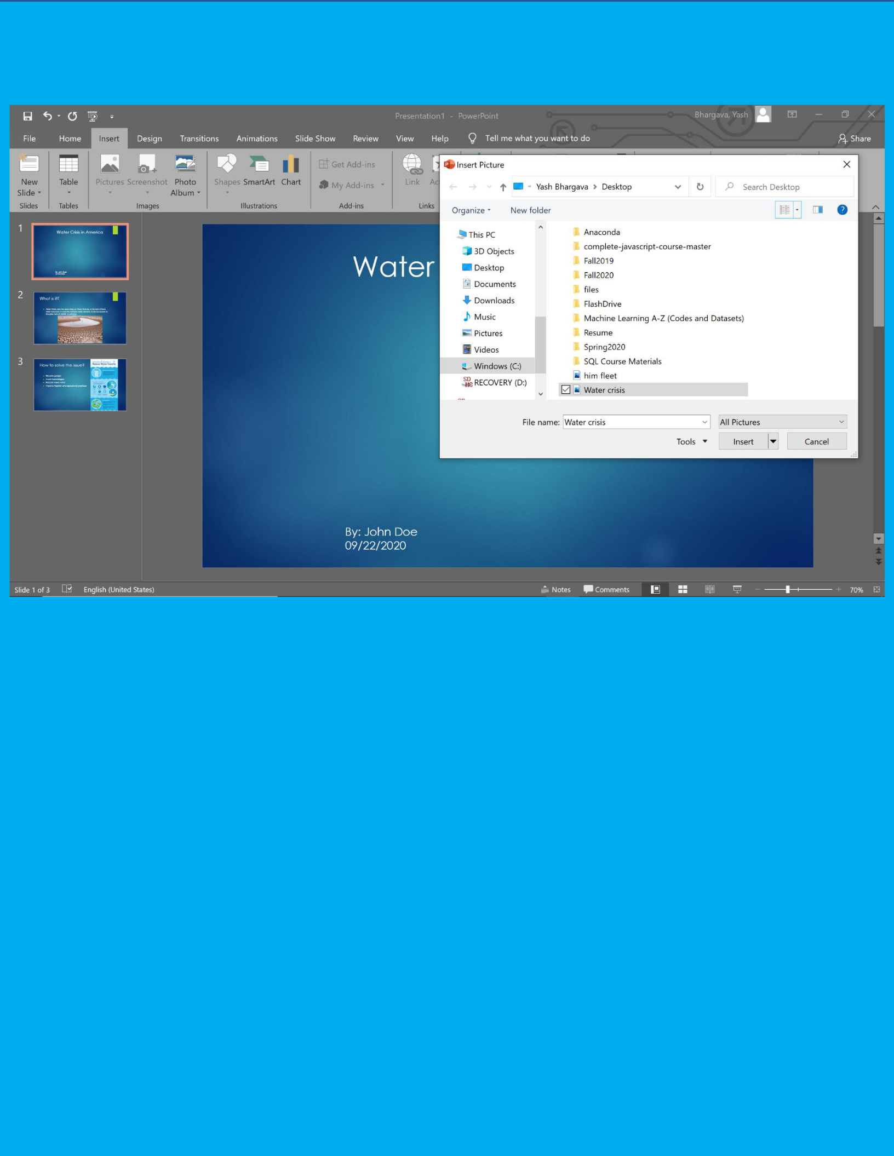

*Figure 9: Image shows the image that will be added to the slide, in this case, the image is called a crisis*

1. Click the insert tab on the top and then click on the little arrow under Pictures. This will then show another 2 options, one that says This Device, which lets you load in an image from your computer, or Online Pictures, which lets you search for an image from the web. Figure 8 shows this.
2. If “This Device” is clicked (labeled 2 in figure 8), navigate to the place where you have your image saved and click ok. The image will now be placed on the slide. Figure 9 shows a similar screen that will pop up when you click this device. Figure 5 shows what the slide will look like after the image has been placed.

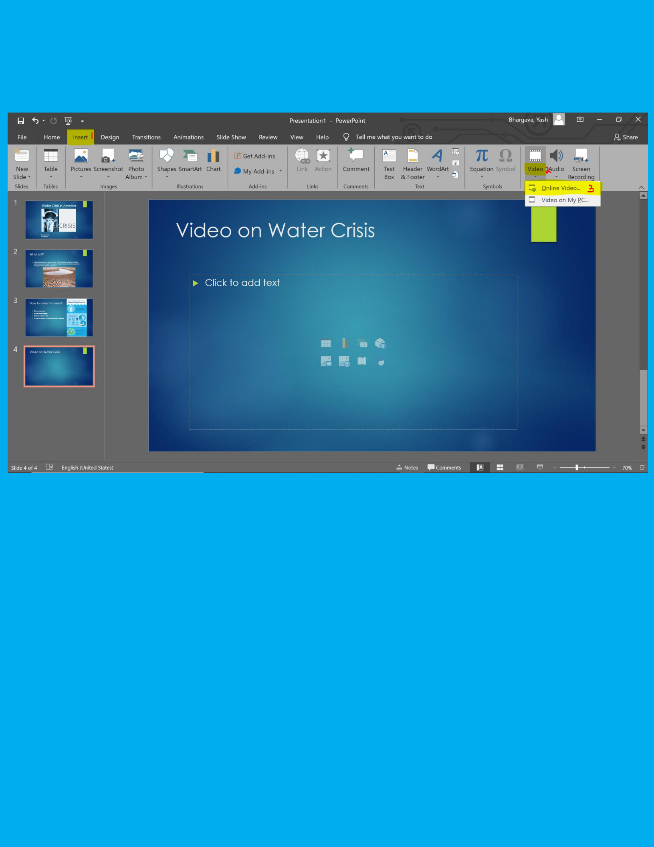**Adding Video**

*Figure 10: Image shows the steps to add a video. Steps are distinguished by numbers*

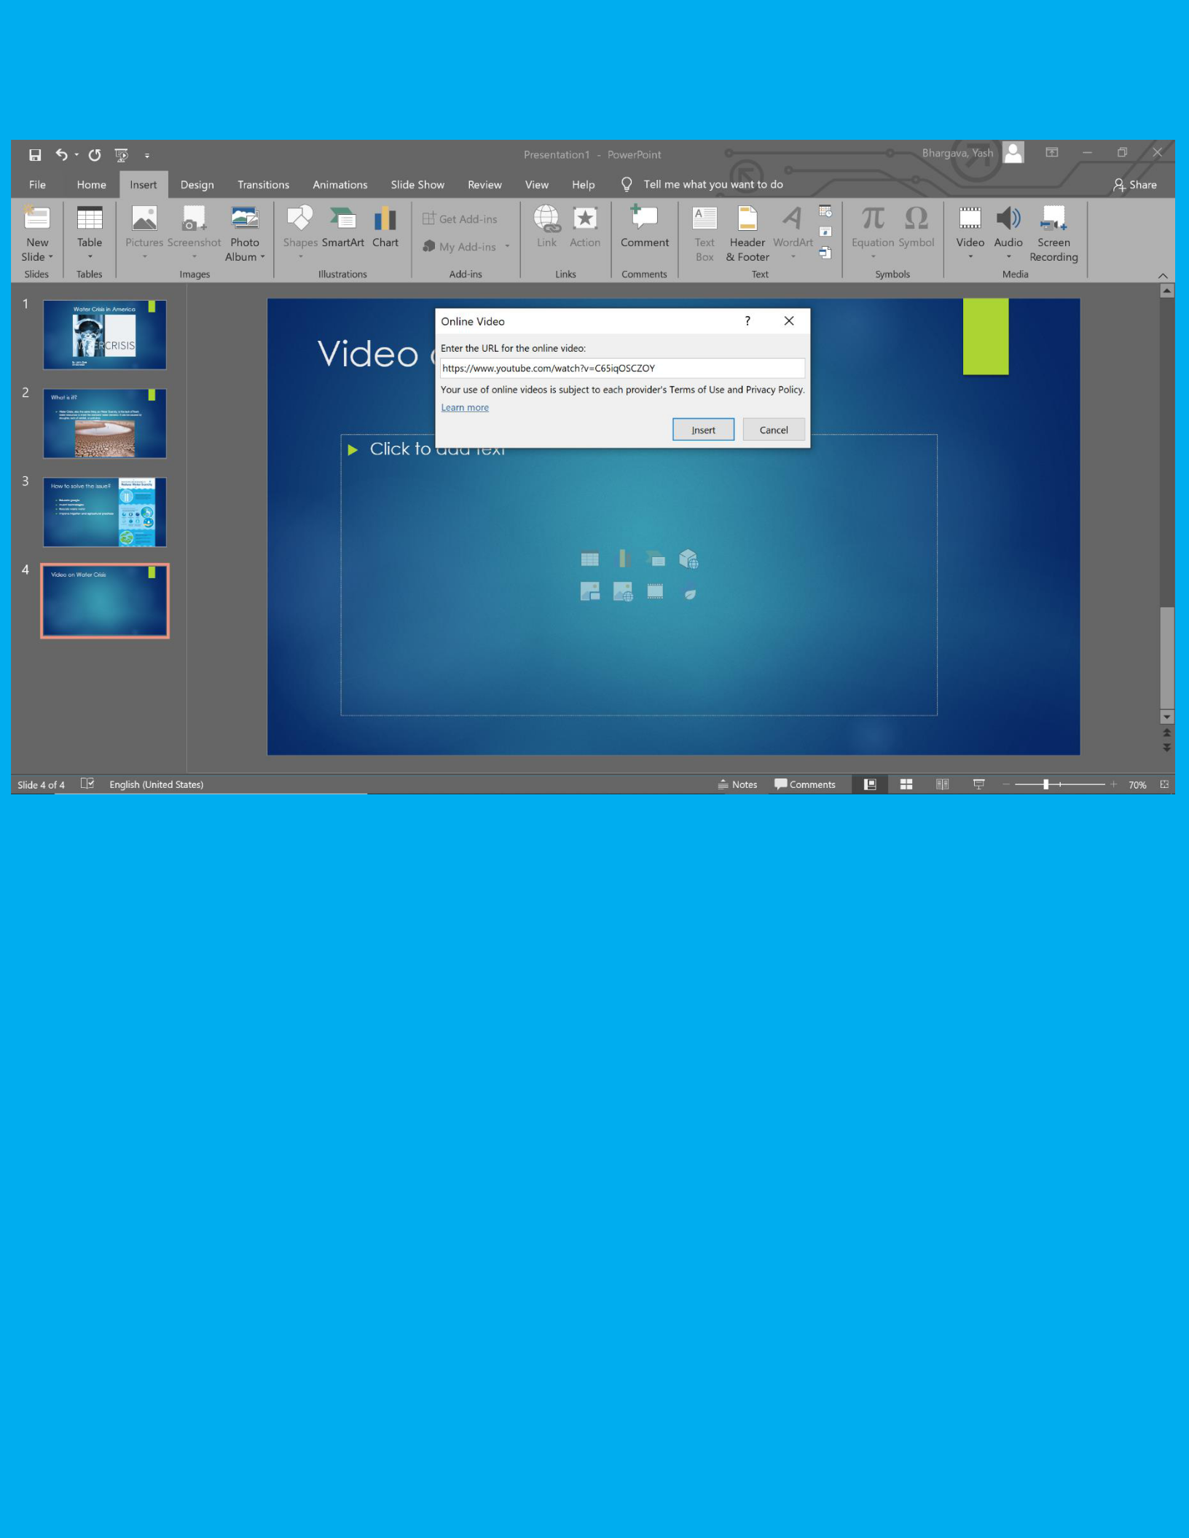

*Figure 11: Image shows an example video to be inserted*

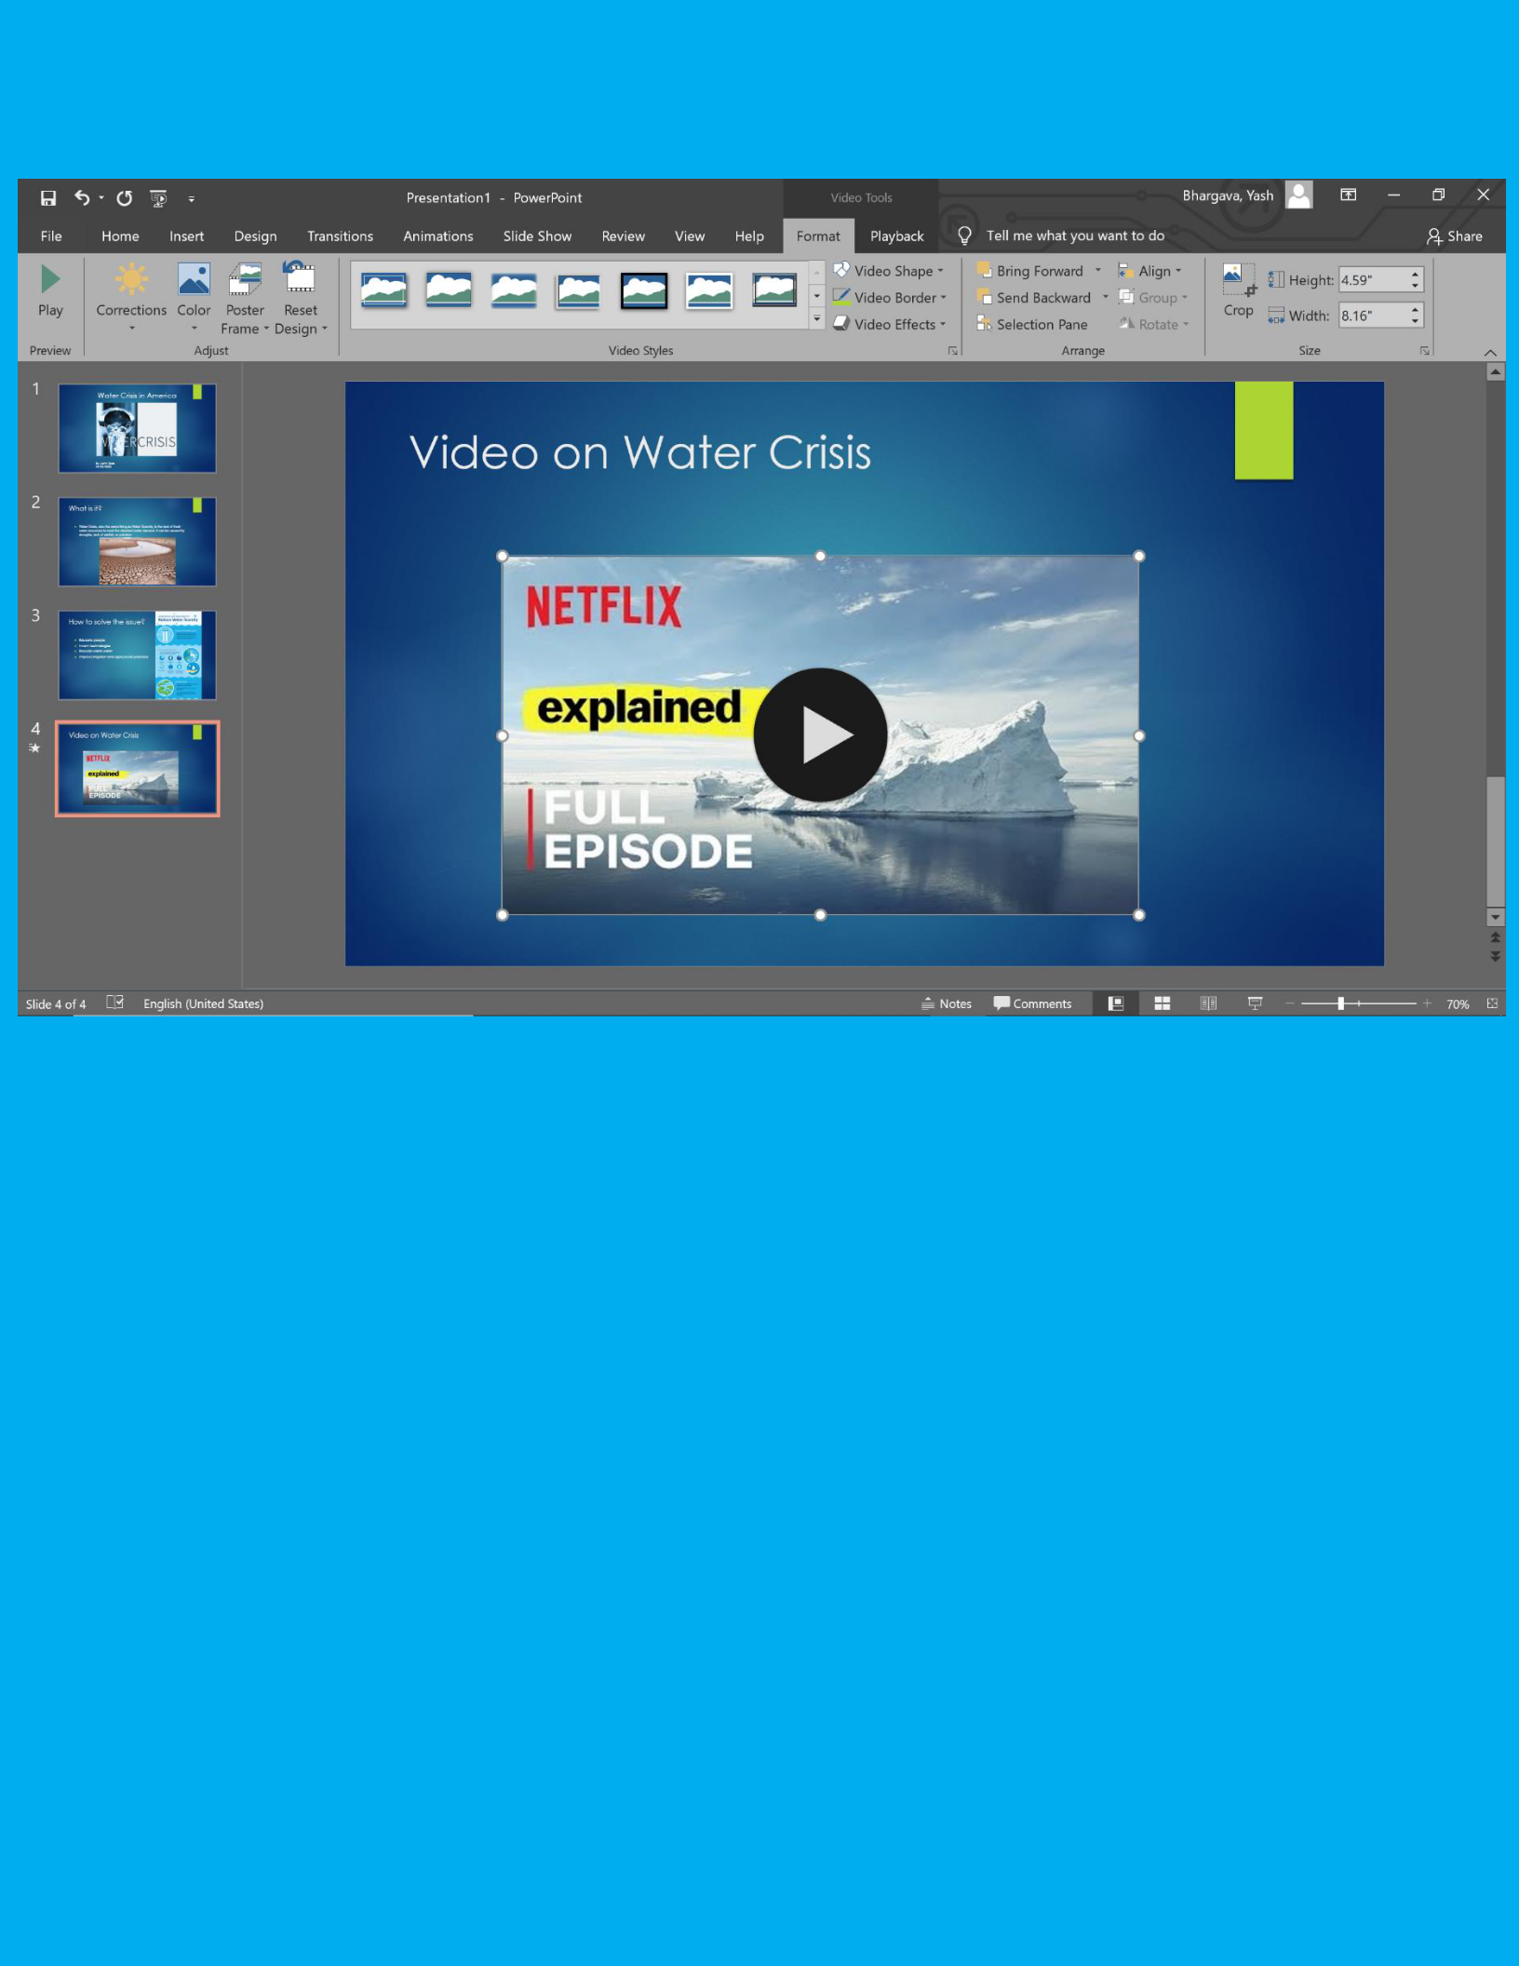

*Figure 12: Image of the video inserted and what slide looks like*

1. Click the insert tab on the top and then click the little arrow under Video, which is on the far right, as highlighted in the image. The little arrow will then pop up with 2 options, one that says Online Video and another that says Video on My PC. Figure 10 shows the steps to take in order to insert video, labeled 1 and 2.
2. If there is a video on your computer, click Video on My PC. Find where the video is stored on your computer and then click it and press ok (just like inserting an image). If you have a video you would like to get from the web, click online video, (Labeled 3 in figure 10) which will then ask for the URL. Type the URL in. Figure 11 shows the URL of a video from YouTube. Click insert. Figure 12 shows the video inserted.

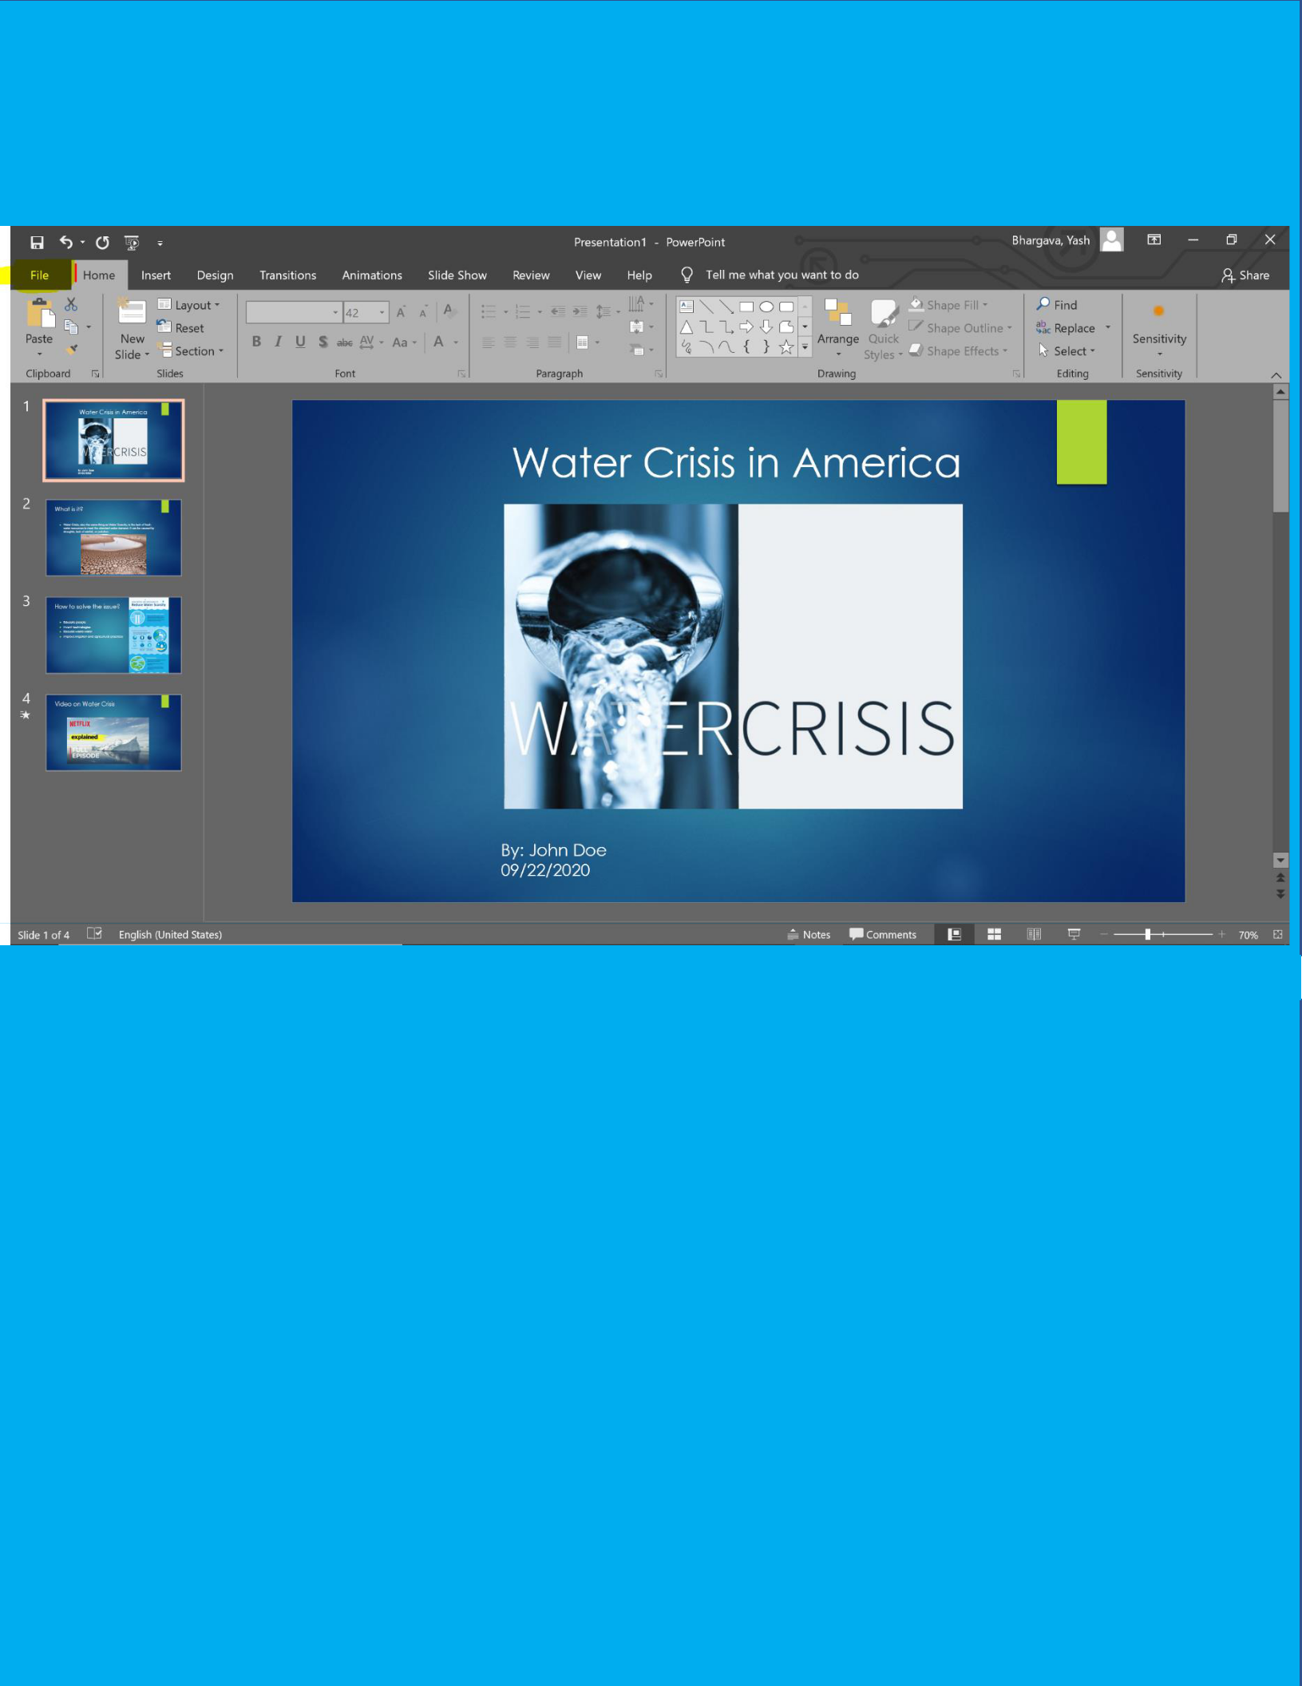**Saving Progress**

*Figure 13: Image shows tab highlighted and labeled in order to save a PowerPoint*

It is crucial to save your progress as you type the information on your slides in order to not lose the progress you have made.

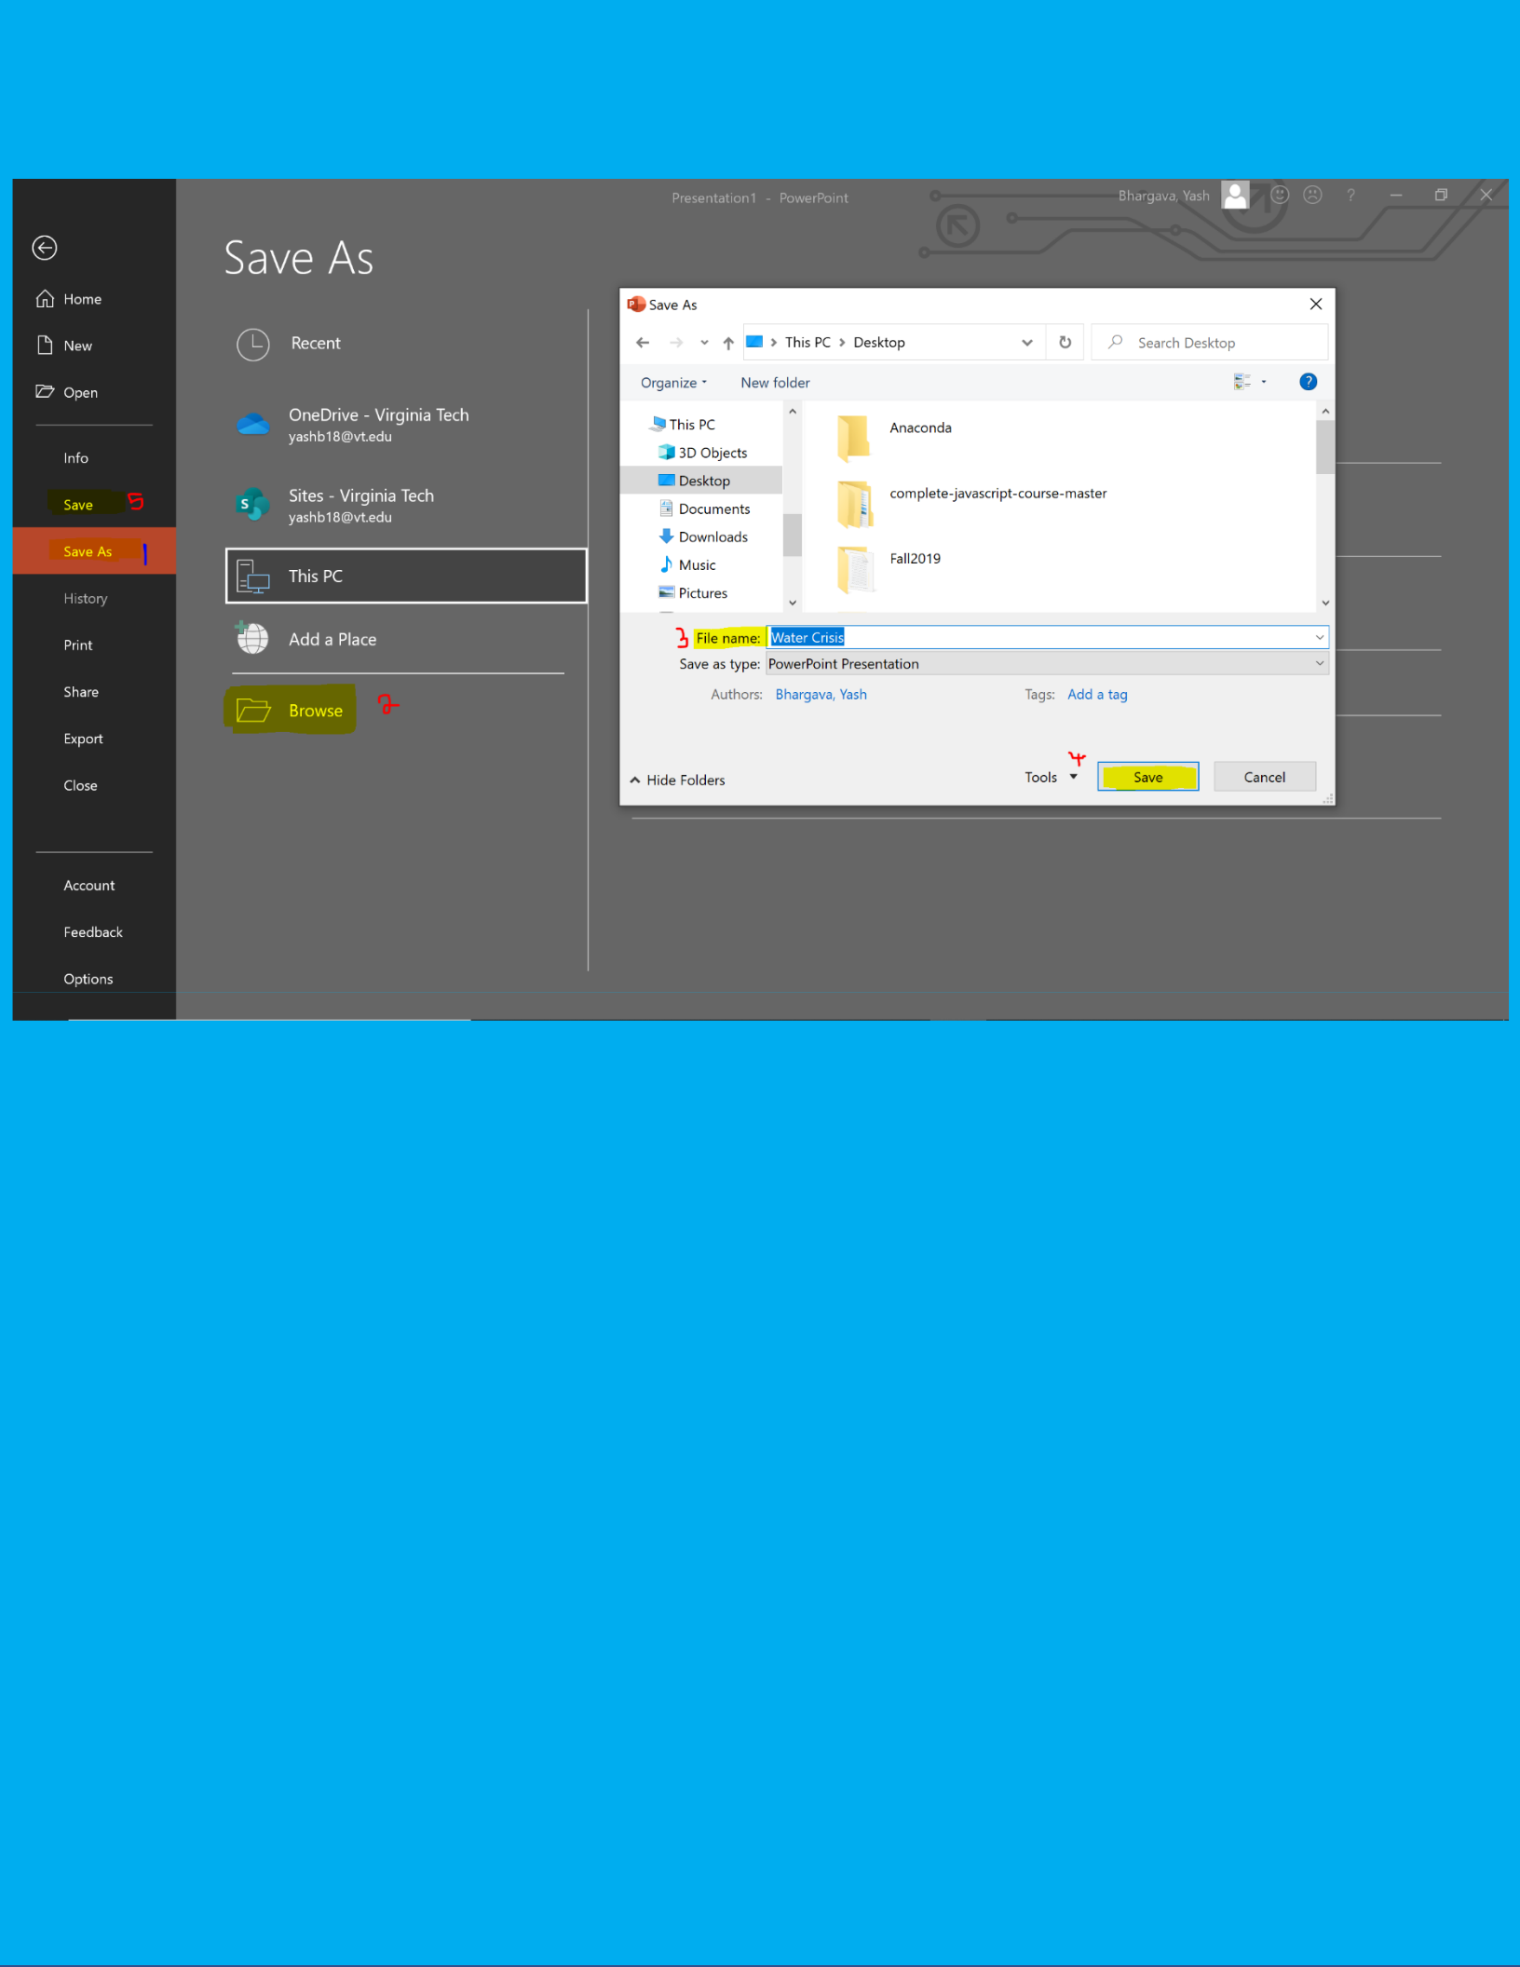

*Figure 14: Image shows the steps to take in order to save a presentation*

To save progress, click the File tab on the top left (Figure 13, Highlighted and Labeled 1). This will open up a page similar to Figure 14. Click Save As (Labeled 1 in Figure 14) from the column on the left. Then click Browse (Labeled 2 in figure 14). This will open up a window with all the locations you can save the PowerPoint. Click the place you would like to save the presentation, name the file where it says File Name (Labeled 3 in figure 14), and then click Save (Labeled 4). The PowerPoint will now be at that location in which you just saved.

**Note:**

**The step above is to be done only once. Once the step above has been completed, you can just click the save button located at the very top and all progress will not be lost. The save button is the very first button in the top left corner. It is also shown in figure 14 labeled 5.**

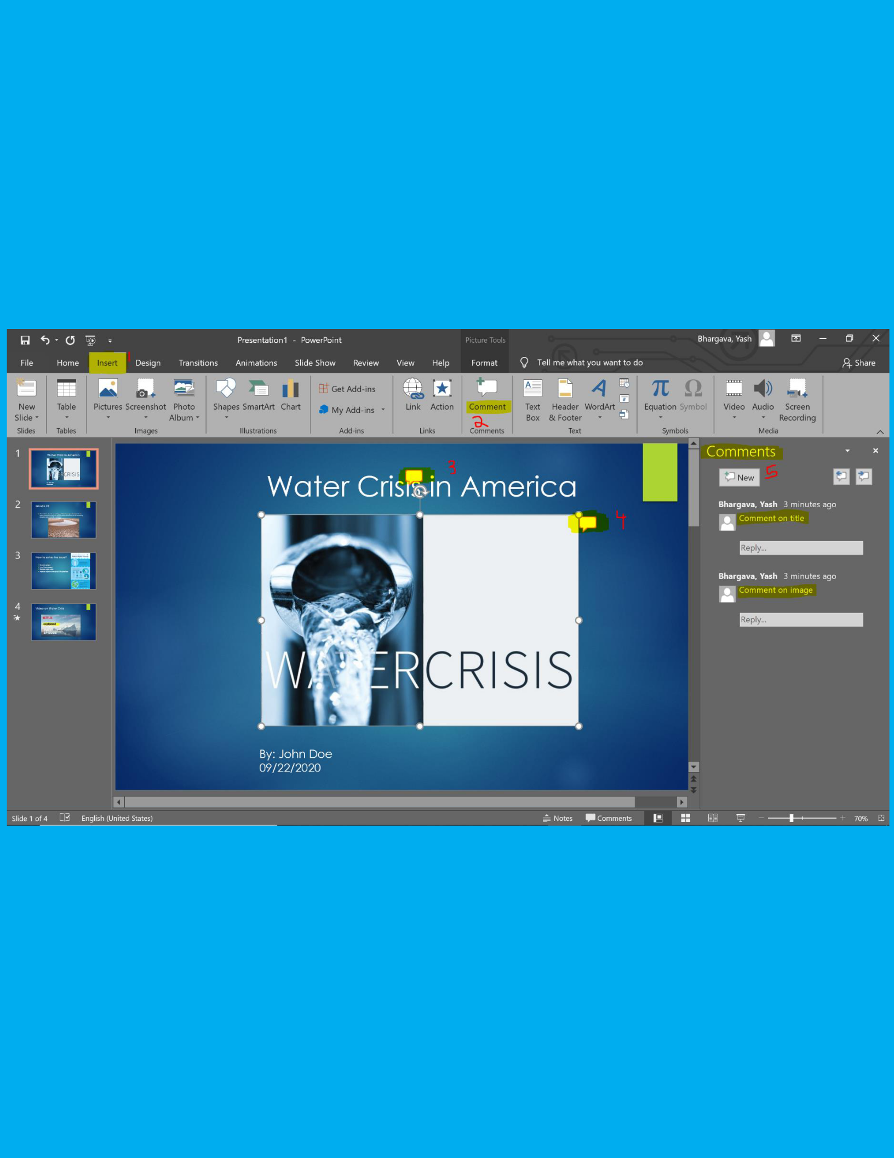**Adding a Comment to Slides**

The importance on adding comments to slides is that it can let you put in information while a presentation is being built and not finished. An example would be to say the title slide needs work and you might forget that, a comment would be inserted to make note of that the next time you work on the presentation. Another use of a comment could be to add an image that you might

forget to.

*Figure 15: Image shows steps to take in order to add a comment*

1. To add a comment, select an item or slide you want to add the comment to, click Insert tab (Labeled 1 in figure 15) and then comment (Labeled 2 in figure 15)
2. A box will pop up as labeled 3 and 4 in figure 15. On the right-hand side, you can add the comment.
3. To add a new comment, press the New button, labeled 5 on the right-hand side of figure 15.

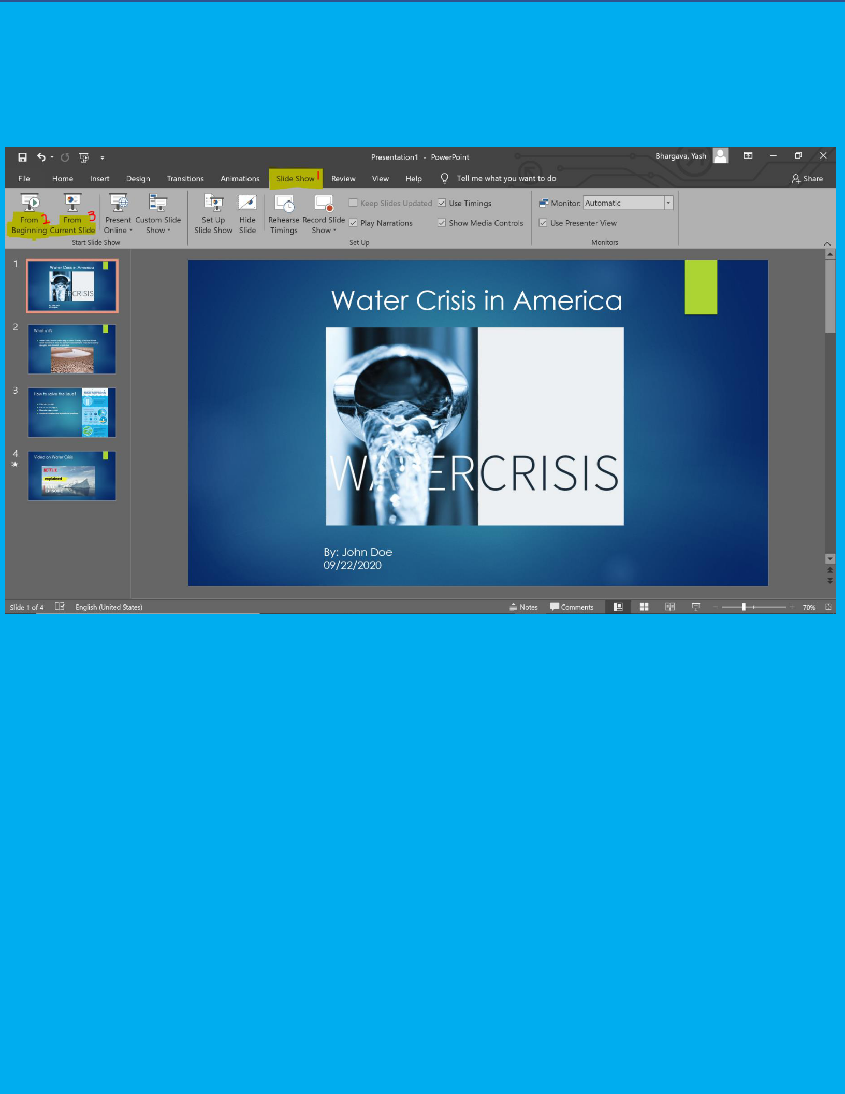**Presenting Slides**

*Figure 16: Image shows steps to present slides*

**The 2 most useful options of presenting are From Beginning and From Current Slide.**

1. To present your slides from the very first slide, click the Slide Show tab on top (Highlighted and labeled 1 in figure 16) and then click From Beginning (labeled 2 in figure 16) , which is the very first option on the left side.
2. To present your slides from a specific slide, first select the slide you would like to present. Click Slide Show tab on top (Labeled 1 in figure 16) and then click From Current Slide (Labeled 3 in figure 16). This will present the slides from the slide you have selected or are currently on.



*Figure 17: Image shows what screen looks like when in presentation mode*

When clicking one of these options, the slides will become full screen. Press enter on your keyboard to go to the next slide, or backspace to go to the slide before, if there is one. There will also be arrows on the bottom left corner of the slide to help you move on to or go back a slide, as shown in figure 17 and labeled 1 and 2. Left arrow takes you back one slide, and right arrow takes you to the next slide.